|  |
| --- |
|  |
| 新概念 3 册 |
| Lesson34 |

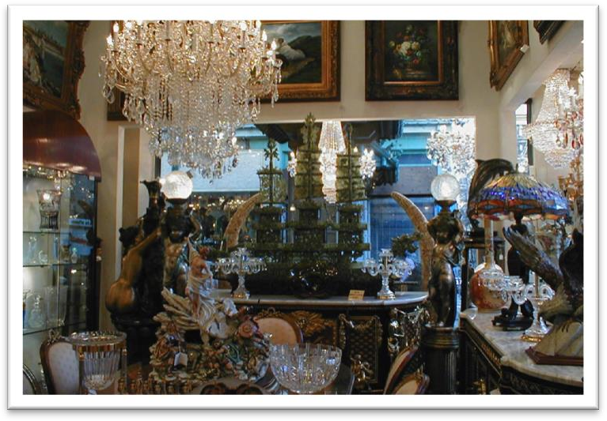Lesson 34 A happy discovery

**forbidding [fə'bɪdɪŋ]**

**adj. 令人望而生畏的；冷冰冰的**

a forbidding place

a forbidding appearance

unfriendly unwelcoming

inhospitable hospitable The Chinese are very hospitable.

The Chinese are noted for their hospitality. forbidden

the Forbidden City the forbidden fruit **muster ['mʌstə(r)]**

v. 鼓起，激起，振作起

muster (up) sth. = summon (up) sth. muster / summon (up) courage muster / summon (up) enthusiasm muster / summon (up) strength **junk [dʒʌŋk]**

n. 废品，破烂货

a piece of junk

The cupboard is full of junk. junk food / mail

clutter

Those who never have to move house become indiscriminate collectors of what can only be described as clutter.

rubbish trash refuse

garbage litter clutter Magazines littered / cluttered the floor.

be littered / cluttered with ...

The garden was soon littered with chunks of metal which had once made up a lawn mower.

dealer ['di:lə(r)]

**n. 商人**

an antique dealer a furniture dealer

businessman / merchant

vendor retailer wholesaler

supplier sales representative assistant / clerk

real estate agent grocer

stationer

cherish ['tʃerɪʃ]

**v. 珍爱，珍视；长期怀有某种感情**I’ll cherish our friendship for ever. treasure value

Mary’s cherished possessions Mary’s prize possessions treasured valued

He cherished the hope of winning an Olympic medal. He cherished the memory of his late wife.

He cherished the illusion that the girl was in love with him. happy: lucky; fortunate

a happy coincidence the happy few

The sad truth is that most of us have been brought up to eat certain foods and we stick to them all our lives.

He made a sad mistake.

I guess I set up the video camera to try and entice Joey. But sadly I could not be enticed.

exert ... on ...

Much as we may pride ourselves on our good taste, we are no longer free to choose the things we want, for advertising exerts a subtle influence on us.

Cats never fail to fascinate human beings. charm attraction appeal

In spite of national differences, certain funny situations have a universal appeal. sth. exert a peculiar fascination on sb.

造句：很多中国年轻人非常喜欢韩国的 (Korean) 电视剧 (TV dramas)。

Korean TV dramas exert a peculiar fascination on a great many Chinese young people.

The more expensive kind of antique shop where rare objects are beautifully displayed in glass cases *to keep them free from dust* is usually a forbidding place.

The expensive shops in a famous arcade near Piccadilly were just opening. a new kind of machine

machines of a new kind (be) free from ...

He may never be sure where the next meal is coming from, but he is free from the thousands of anxieties which afflict other people.

The composition is free from errors.

Organic produce is free from harmful chemicals. free ... from ...

He dedicated his life to freeing the world from famine and disease. pretentious adj. 自命不凡的；装腔作势的

造句: 谁也不用壮着胆子去接近一个不那么装腔作势的女孩子。

No one has to muster up courage to approach a less pretentious girl.

There is always hope that in its labyrinth of musty, dark, disordered rooms a real rarity will be found *amongst the piles of assorted junk that litter the floors*.

there be + 无灵主语there is no denying that ... there is no doubt that ...

there is every likelihood that ... there is little likelihood that ... there is no shortage of ...

Of course, New York is the ideal place for such an interesting study, because there is no shortage of tall buildings.

there is an element of truth in ...

Perhaps there is an element of truth in both these pictures, but few of us have had the opportunity to find out.

there is a good deal of truth in ...

Apparently, there is a good deal of truth in this idea. There is little hope of any improvement in his condition.

There's still a faint hope that the two sides will reach an agreement. It was rush hour, and there was no hope of getting a seat.

Is there any hope of getting financial support for the project? Is there any hope that she will change her mind?

*a boy* of a girl

*an angel* of a wife

*a palace* of a house

*a garden* of Switzerland

Jane is *a submissive lamb* of a girl. amongst: among

whilst: while midst: middle

assorted vegetables

a box of assorted chocolates tools in assorted sizes swimsuits in assorted colors

by chance by accident accidentally intentionally deliberately on purpose No one succeeds by chance.

A truly dedicated bargain hunter must have *patience*, and above all, *the ability to recognize the worth of something* when he sees it.

above all (else)

Max is clever, hardworking, and above all (else) honest.

造句：一个真正全身心投入的猎头必须要有耐心，并且最重要的是，要有识才的慧眼。

A truly dedicated head-hunter must have patience, and above all, an eye for talents. He has an eye for beauty.

When at Rome, do as the Romans do. When at Rome, do like the Romans.

... Alfred Bloggs who worked as a dustman for the Ellesmere Corporation. She spoke as a lawyer.

She spoke like a lawyer.

He must be as knowledgeable as the dealer (is). He isn’t as / so knowledgeable as the dealer (is).

*Like a scientist bent on making a discovery*, he must cherish the hope that one day he will be amply rewarded.

be bent on sth. / doing

The boy is bent on mischief.

He is bent on winning at all costs. be determined to do

be resolved to do

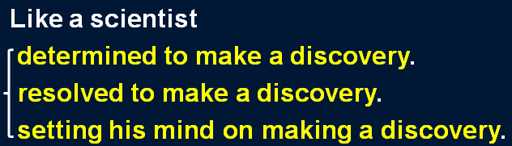set one’s mind on sth. / doing

nourish

Lisa has long nourished the hope of becoming a ballerina.

The city at one time must have been prosperous, for it enjoyed a high level of civilization. There is a lot of beautiful scenery in China.

China boasts a lot of beautiful scenery. They have three lovely children.

They are blessed with three lovely children. The girl has both beauty and brains.

The girl is endowed with both beauty and brains. be rewarded

be amply rewarded

There is always hope that all my patience will be amply rewarded.

He has often described *to me* how he picked up a masterpiece for a mere £50. describe … to sb.

Let me describe *to you* how it happened.

Wherever it went, it left *behind it* a trail of dead deer and small animals like rabbits. On the occasions when they have pushed *to shore* an unconscious human being … describe … as …

He described it as 'a very agreeable situation located within two small hills in the midst of which flowed a great river.'

Those who never have to move house become indiscriminate collectors of what can only be described as clutter.

pick sth.↔up

We managed to pick up a few bargains at the auction. a mere … 仅仅……

He's a mere child.

It took her a mere 20 minutes to win.

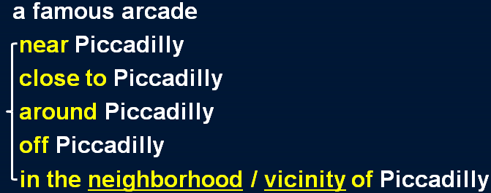Glancing at his map, he informed us that the next village was a mere twenty miles away.

The latest exhibitions, films, or plays are only a short bus ride away. only a short bus ride away

within walking distance within driving distance within commuting distance only a stone’s throw away

Having never been there before, ... As this was his first visit there, ... This being his first visit there, ...

The dealer told him that it had just come in, but that he could not be bothered to open it.

Galileo’s observations show (that) Copernicus, another great astronomer, was right and that the earth moves around the sun, not the other way around.

He agreed that a train did come into the station at the time on the paper and that it did stop, but only to take on mail, not passengers.

can't be bothered (to do sth) 嫌麻烦（而不愿……）

The grass needs cutting but I can't be bothered to do it today.

He could produce excellent work but usually he can't be bothered.

When the journalist again failed to reply, the editor reluctantly published the article as it had

originally been written.

unwillingly with reluctance prise / pry sth. open

*Apart from an interesting-looking carved dagger*, the box was full of crockery, much of it broken. apart from ... / aside from ...

except ... / except for ... but / but for ... excluding ...

other than ...

with the exception of ...

Apart / Aside from the ending, it's a really good film.

I hardly know anyone in town apart / aside from William and you. besides

as well as ...

in addition to ...

Apart / Aside from the injuries to his face and hands, he broke both legs.

Apart / Aside from these two books, he has written some plays and film scripts.

... the box was full of crockery, and much of it was broken.

... the box was full of crockery, much of which was broken.

造句：这个箱子 (chest) 里除了一些金条 (gold bullion) 之外, 装满了宝石 (precious stone),

其中大多数都是钻石。

Apart from some gold bullion, the chest was full of precious stones, most of them diamonds. As its composition and line reminded him of an Italian painting *he knew well*, he decided to buy it.

remind sb. of sth.

That song always reminds me of our first date. remind sb. about sth.

remind sb. to do sth.

Can you remind us about your plans for the building? Remind me to buy some milk tonight.

Its composition and line *reminding him of an Italian painting he knew well*, he decided to buy it. Glancing at it briefly, the dealer told him *that it was worth £50*.

Glancing at his map, he informed us that the next village was a mere twenty miles away.

I had no intention of buying one, but I could not conceal the fact that I was impressed by the size of the diamonds.

Frank almost revealed his excitement.

His function is analogous to that of a judge, who must accept the obligation of revealing in as obvious a manner as possible the course of reasoning which led him to his decision.